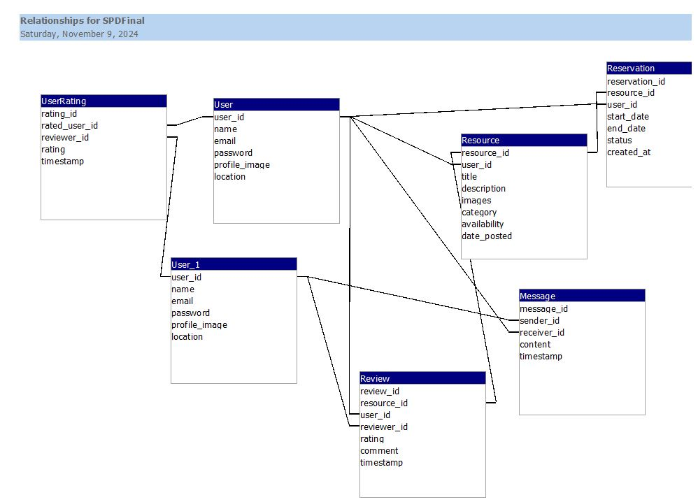

### **1. Database Schema**

**Tables and Columns**:

* **User Table**:
  + user_id (Primary Key)
  + name (String)
  + email (String, unique)
  + password (String, hashed)
  + profile_image (String, URL or file path)
  + location (String)
* **Resource Table**:
  + resource_id (Primary Key)
  + user_id (Foreign Key referencing User.user_id)
  + title (String)
  + description (Text)
  + images (String, URL or file path)
  + category (String)
  + availability (String)
  + date_posted (Date)
* **Message Table**:
  + message_id (Primary Key)
  + sender_id (Foreign Key referencing User.user_id)
  + receiver_id (Foreign Key referencing User.user_id)
  + content (Text)
  + timestamp (Datetime)
* **Review Table**:
  + review_id (Primary Key)
  + resource_id (Foreign Key referencing Resource.resource_id)
  + user_id (Foreign Key referencing User.user_id) – the user who created the review
  + reviewer_id (Foreign Key referencing User.user_id) – the user who left the review
  + rating (Integer, e.g., 1-5)
  + comment (Text)
  + timestamp (Datetime)
* **Reservation Table**:
  + reservation_id (Primary Key)
  + resource_id (Foreign Key referencing Resource.resource_id)
  + user_id (Foreign Key referencing User.user_id)
  + start_date (Date)
  + end_date (Date)
  + status (String, e.g., 'pending', 'approved', 'declined')
  + created_at (Datetime)
* **UserRating Table**:
  + rating_id (Primary Key)
  + rated_user_id (Foreign Key referencing User.user_id) – the user receiving the rating
  + reviewer_id (Foreign Key referencing User.user_id) – the user giving the rating
  + rating (Integer, e.g., 1-5)
  + timestamp (Datetime)

### **2. ER Diagram Explanation**

**Relationships**:

* **User and Resource**:
  + A User can create multiple Resources (one-to-many relationship).
* **User and Message**:
  + A User can send and receive multiple Messages (one-to-many relationship for both sender and receiver).
* **User and Review**:
  + A User can leave reviews on Resources, and a Resource can have multiple Reviews.
  + A Review is linked to the User who created the resource and the Reviewer who wrote the review.
* **User and Reservation**:
  + A User can make multiple Reservations (one-to-many relationship).
* **Resource and Reservation**:
  + A Resource can have multiple Reservations (one-to-many relationship).
* **UserRating**:
  + Represents a User receiving ratings from other users. Each record links the rated_user_id with the reviewer_id.

### **3. ER Diagram Description**

Here is a textual description of the ER diagram relationships:

* **User**:
  + Primary Key: user_id
  + Relationships:
    - **has** Resources (one-to-many)
    - **sends** and **receives** Messages (one-to-many)
    - **writes** Reviews for Resources (one-to-many)
    - **receives** UserRatings (one-to-many)
* **Resource**:
  + Primary Key: resource_id
  + Foreign Key: user_id (references User)
  + Relationships:
    - **has** Reviews (one-to-many)
    - **has** Reservations (one-to-many)
* **Message**:
  + Primary Key: message_id
  + Foreign Keys: sender_id, receiver_id (both reference User)
* **Review**:
  + Primary Key: review_id
  + Foreign Keys: resource_id (references Resource), user_id, reviewer_id (both reference User)
* **Reservation**:
  + Primary Key: reservation_id
  + Foreign Keys: resource_id (references Resource), user_id (references User)
* **UserRating**:
  + Primary Key: rating_id
  + Foreign Keys: rated_user_id, reviewer_id (both reference User)